**STARAGILE ANSIBLE ASSIGNMENT -1**

**Step 1: Create 2 AWS Ubuntu Instances**

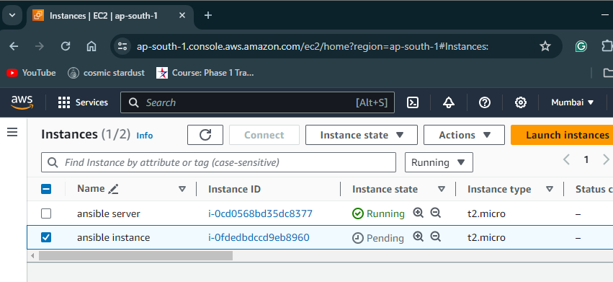

**Step 2: Setup Ansible on one instance**

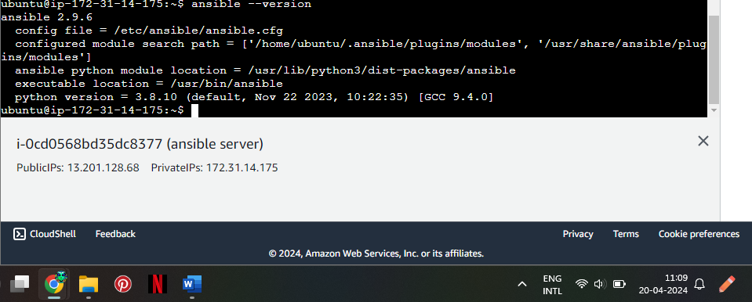

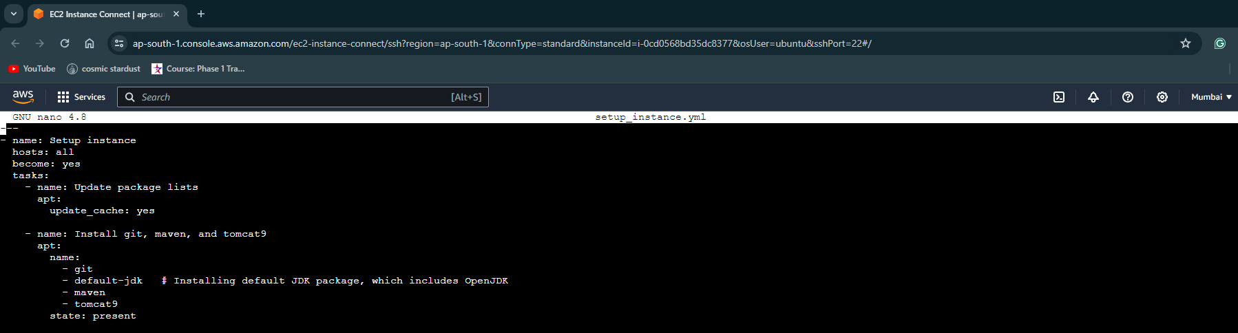

**Step 4: Configure hosts inventory file**

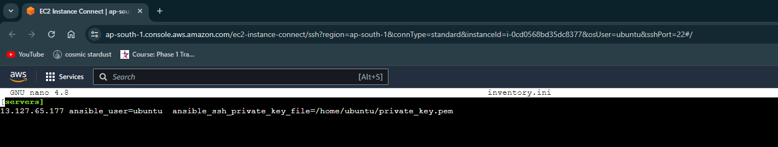

**Step 5: Execute the playbook**

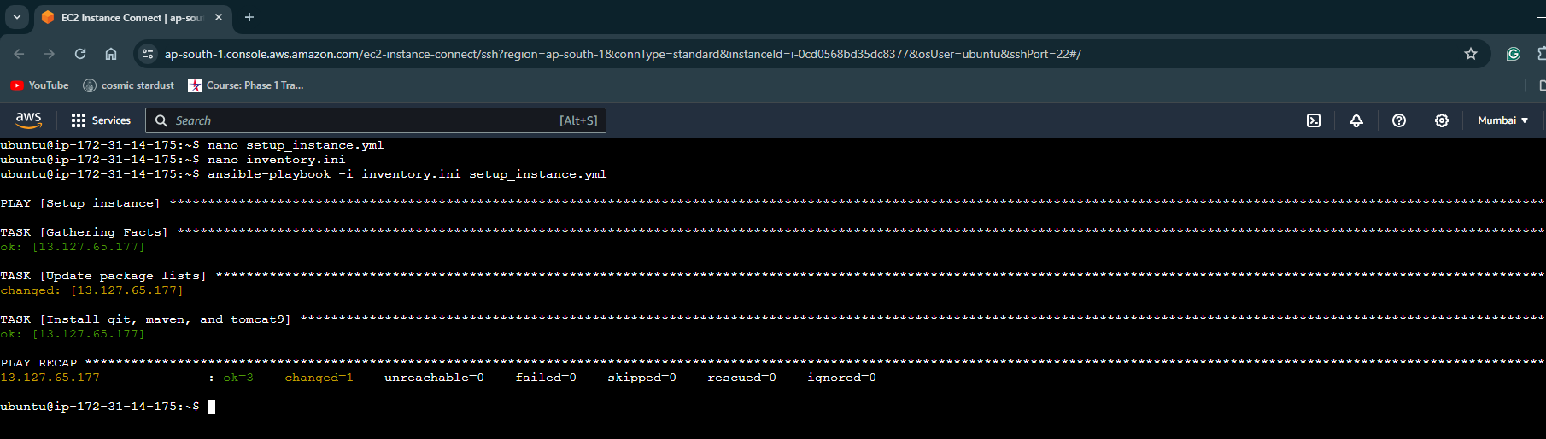

**Step 6: Validate the configuration**

SSH into the other instance and run the following commands to validate the installation:

